# Front-end Developer Exam (Angular / ReactJS / VueJS)

You have 3 hours to finish the test.

In this exam, you will be required to solve various problems utilizing Angular / React / VueJS.

**Using third-party libraries are not allowed** unless explicitly required by the test!

**Important notes**

1. Please remember that even if you don't have any prior experience with the following concepts try to solve them in the best possible manner.
2. Remember that it is more important for us to see what you have accomplished and the approach you have taken for finding the solution.

# What should you implement?

In this exam, you will be required to develop an interactive memory game.

The application should create a sequence of illuminations that the user should remember and then repeat on his own.

# Game Rules

The board consists of 6 “light bulbs”, each one has a unique color. The game goes in the following order:

1. Welcome Page - Users should be able to enter their name and open the game interface
   1. After entering his name, the user can start the game by clicking the “Start” button.
2. Game Page
   1. Play Board
      1. Showing the player name
      2. Showing the current score
      3. Showing the best score
      4. Game process
         1. One of the bulbs should be illuminated by the application.
         2. The user should click the bulb/s in the same order
            1. If the user clicked the right bulb/s at the right order:

The total score should be raised by 10.

Return to step 2.iv.1 and repeat the same sequence of lighting bulbs, adding one additional bulb to it.

* + - * 1. Otherwise

The game is over and the user can restart the game.

* 1. Score History - Sidebar
     1. Score history will display in the left sidebar as well as game details such as the name of the player, date, and time.
     2. The order of the scores will be from the highest to the lowest score.

# Explanation of the game

1. **First illuminated bulb**

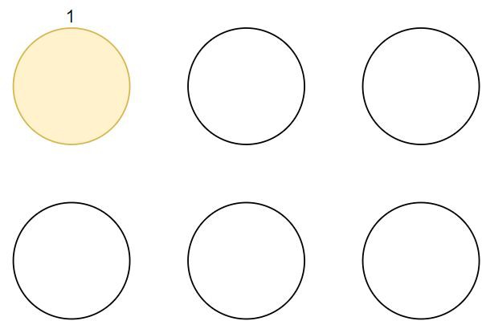

The user clicks the bulb in the right sequence, the user score is 10.

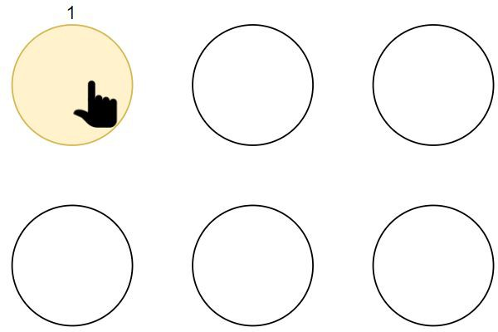

1. **Second illuminated bulb (sequence of 2 illuminations)**

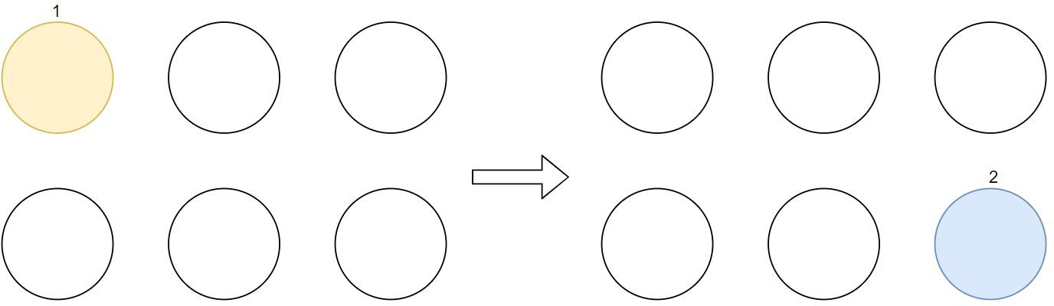

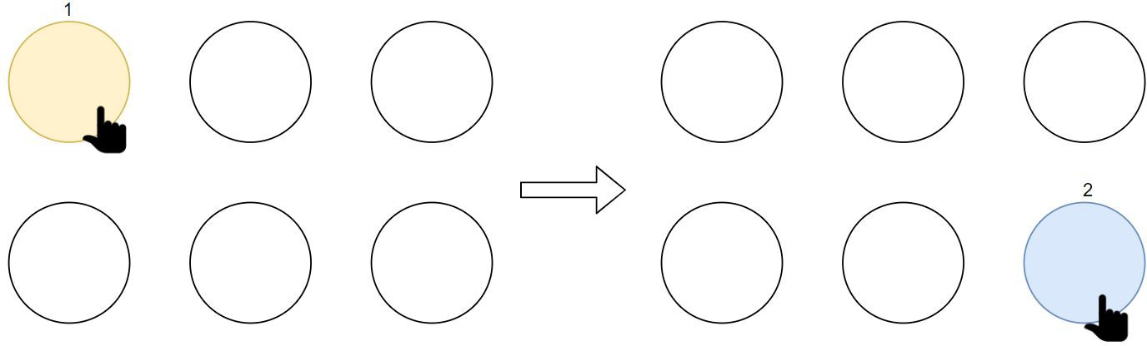

1. **Third illuminated bulb (sequence of 3 illuminations)**

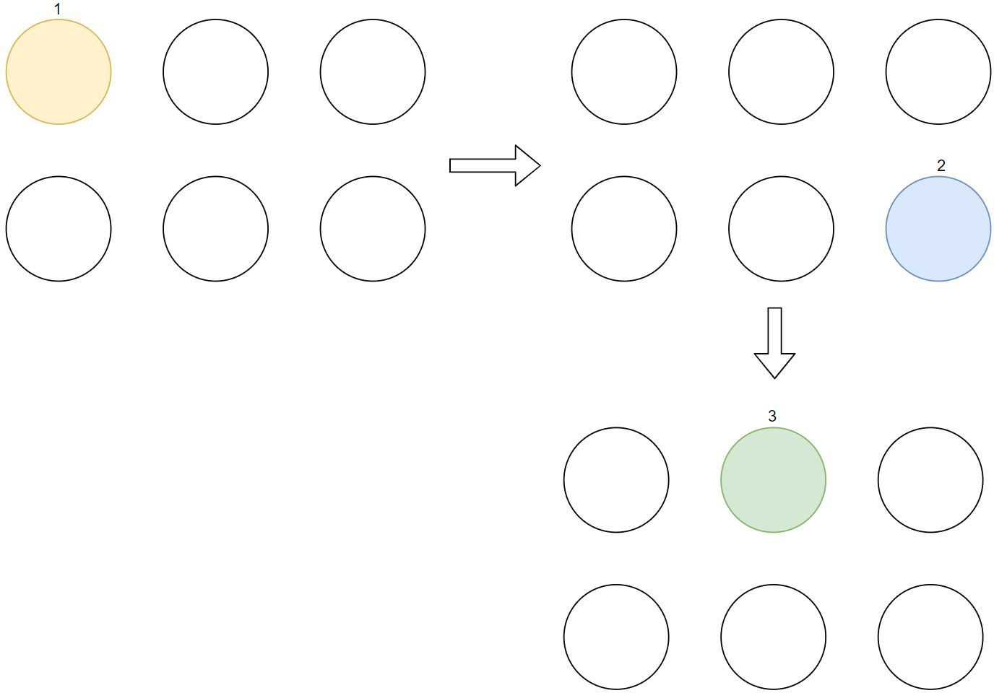

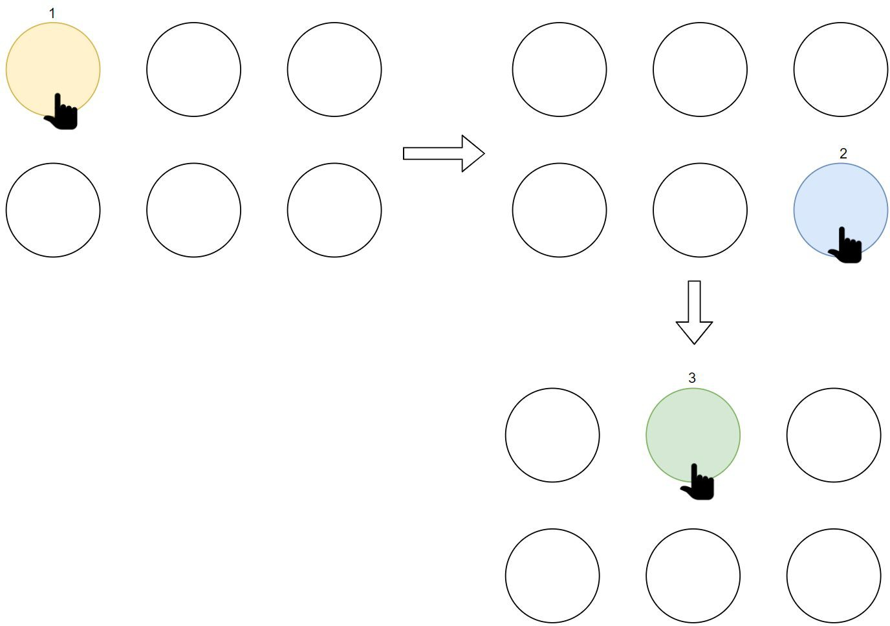

1. **Forth illuminated bulb (sequence of 4 illuminations)**

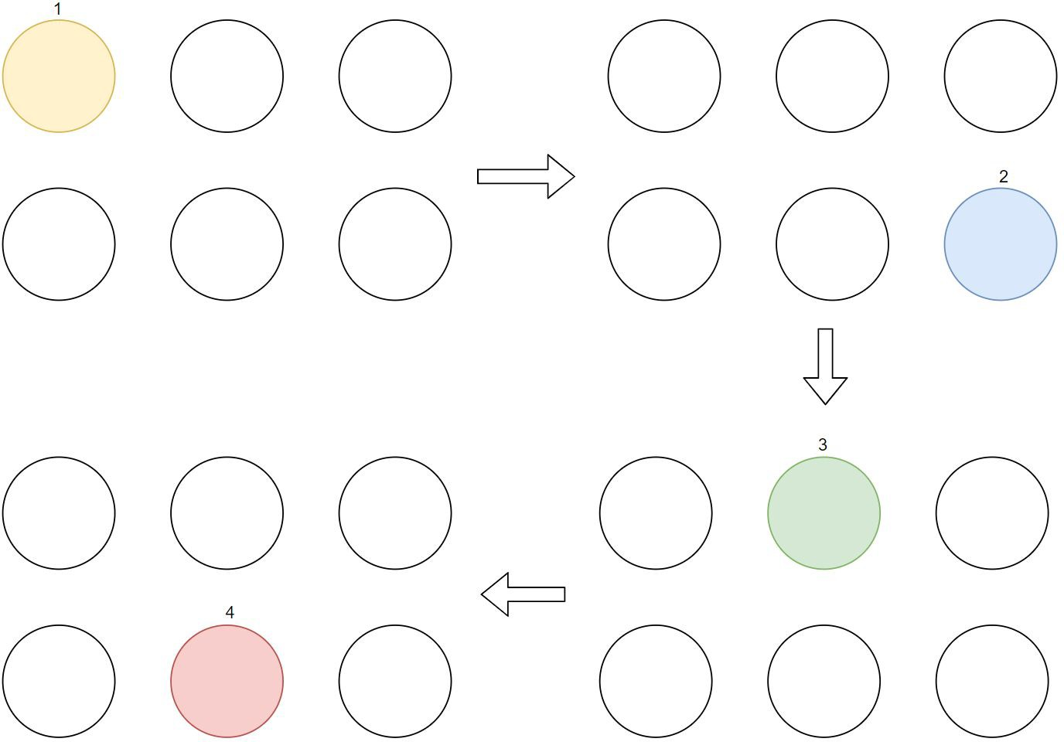

The user clicks the bulb in the wrong sequence, the user score is 30 and the game is over.

